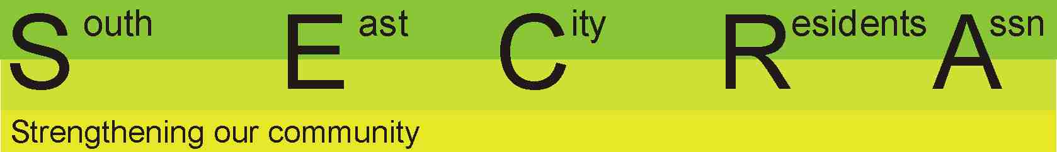
SECRA Membership/ Membership Renewal Application
Name

Family members

Address

Preferred contact telephone number

Email

Annual Subscription – please type X in the appropriate box

Individual $20.00 |  |  |  | Family $30.00 |  |  |  |  | Associate $20.00 |  | Donation | $
Payment – please type X in the appropriate box

Cheque |  | Money Order |  |  |  |  | Payable to: South East City Residents Association  Mail to: The Treasurer, SECRA  PO Box 7017 Hutt Street  Adelaide SA 5000  Email: secra.sa@gmail.com
EFT  (Electronic Funds  Transfer) |  |  |  |  | Account name: South East City Residents Association  BSB: 105 148 Account number: 024 710 940  Please include your initials and surname as the payment reference
By completing, dating and returning this form to SECRA by email secra.sa@gmail.com or post you agree to the following:
If applying for Member or Family Membership: I confirm that I reside in the area covered by the South East City Residents Association.
I support the Objects and Objectives of the Association and agree to abide by the rules in accordance with the Association’s Constitution.

Date:

